

DYNAMICS TMS

Objectives:
- NEXTStop OPS Page

Introduction:
NEXTStop OPS facilitates the management of all internal load postings and bids.

NEXTStop Ops

This feature facilitates the process of managing all loads that have been submitted for bid to your internal carrier base already set up in TMS. Carriers that have been granted access to the Carrier portal system, will have visibility of all loads to bid on in their NEXTStop Carrier screens. This access does require carrier users to be set up and the Load Posting Carrier setup. See your System Admin on setting up Load Posted Carrier and New Carrier User access.

How to Post a Load -Desktop Client
1) Desktop Client – Go to the Load Detail screen. Click on Post Load.
2) The Load Board Selection screen will open. Check NEXTstop.
3) Click Post. DAT requires a separate subscription. Inquiry via support.
4) The load will go to “PC” status and Post to NEXTstop portal.
NO EMAIL NOTIFICATION IS SENT TO THE CARRIERS. USERS SHOULD SEND OUT AN EMAIL.

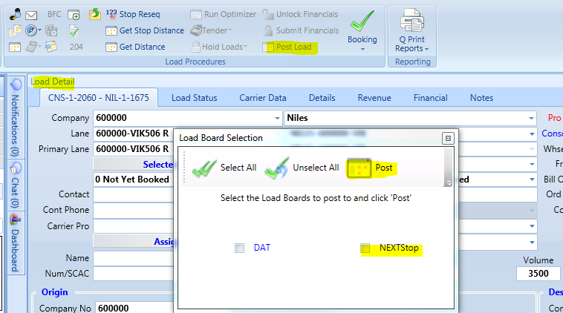

How to Post a Load – Web Client
1) Go to Load Board in Web Client. Click Rate It in the Actions Menu.
2) Turn ON Post to NEXTstop
3) Click the Rate It save button.
NO EMAIL NOTIFICATION IS SENT TO THE CARRIERS. USERS SHOULD SEND OUT AN EMAIL.
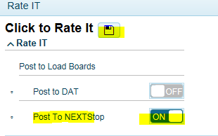
To review Posted Loads - In the menu tree you will see NEXTStop, click and expand the black arrow.
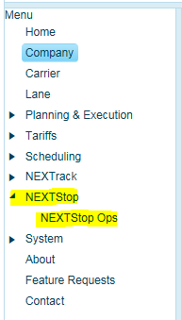
When you enter into the page, you will see the Pending bids (bids that have been posted by TMS user), Active bids (bids that have been submitted by carriers), and Finalized bids (bids that have been awarded to carriers)
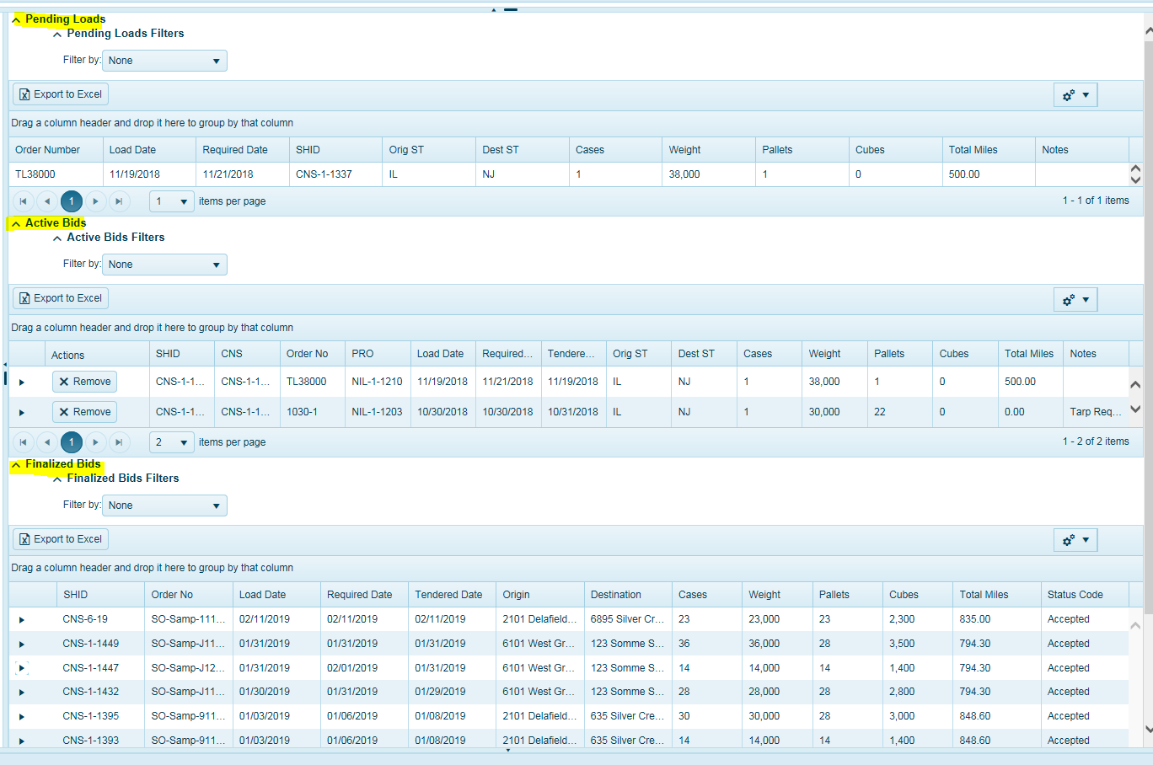

Pending Bids
These are bids that have been submitted to carriers. Click on the settings drop down to change your field chooser display.
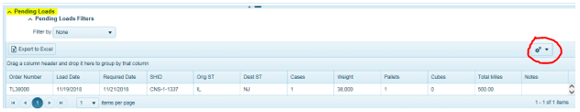

Active Bids
Active bids are bids that have been submitted by 1 or more carriers. Note, you will also see the same load appear in the Pending bids indicating an active bid.
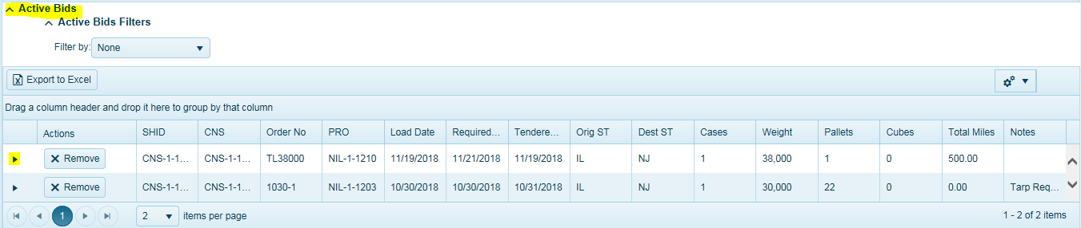
As carriers place their bid, you will see each carrier’s bid by clicking and expanding the black arrow.
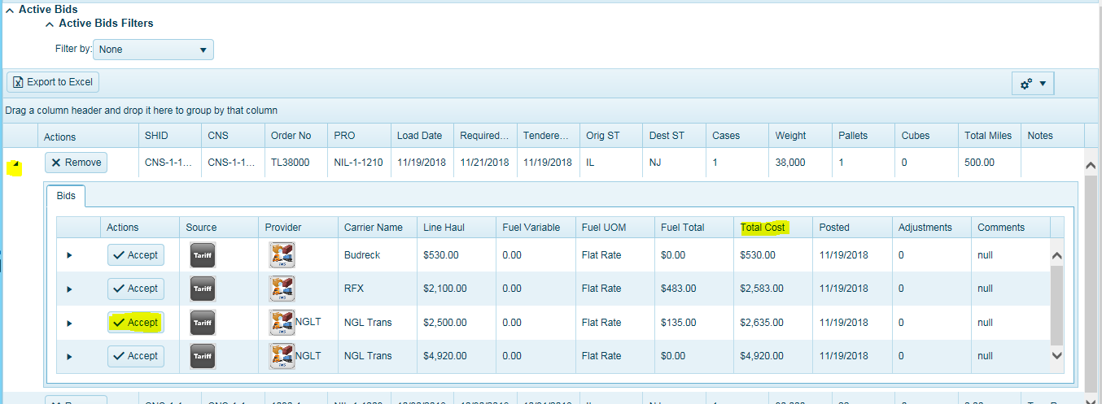
The display will show all carrier bids in addition to any tariffs that you may have in the system to compare bid rate against a tariff rate or even a benchmark. The tariff icon (Black icon) will indicate this is a tariff rate or the NEXTStop icon (Green icon) indicates a bid. Blue Icon indicates API rate.
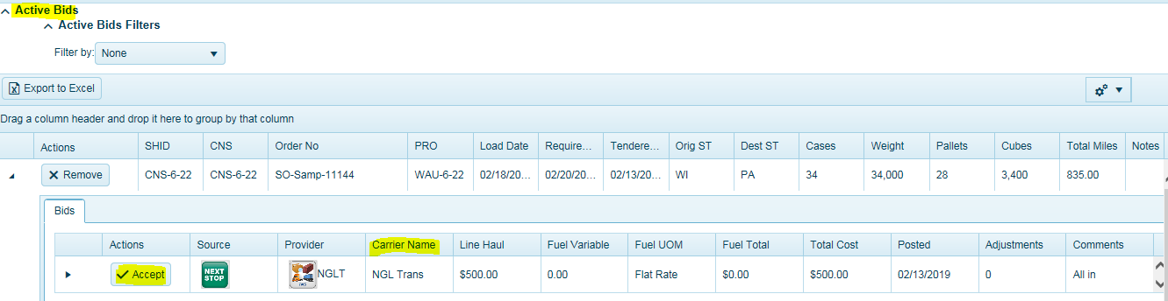
The total cost column will be your all-inclusive rate from the carrier.
Click Accept to accept the Bid and award to a carrier.
An email will be sent to the carrier with the tender report and directing them to login and accept the bid. Users must have carrier contact emails configured correctly to receive tender emails. Carriers will see this tender request in the Tender page. Carriers must accept load in Tender Page.
To Remove a Bid
To remove a bid from being posted, you must click on the REMOVE button which will delete the posting from displaying on the NEXTStop Carrier screens as well as the NEXTStop Ops pending bids page.
Once clicked, the load will be set to “N” status.
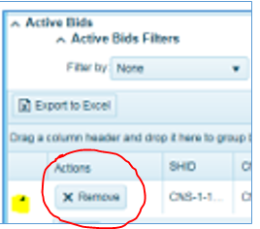
Note, Bid Postings will automatically appear in the Carrier’s Portal Access under NEXTStop Carrier. No email will be sent out notifying carriers of the bid request. If required, users should send a separate email blast.

Finalized Bids
Accepted bids will move to the Finalize tab and display a status code of Accepted, meaning the TMS user has accepted this bid and it has been tendered to the carrier.
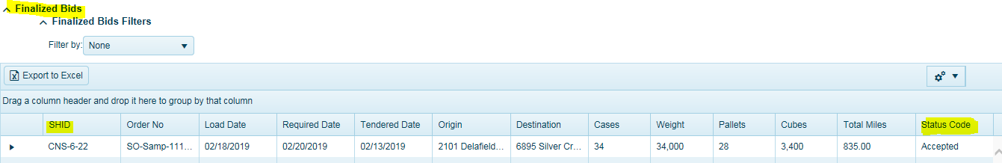
To see the status of the load, go to the Load Board and apply your filter to show all loads in PC (tendered) status. When a user accepts the bid the system will move the workflow to PC status (tendered) automatically.
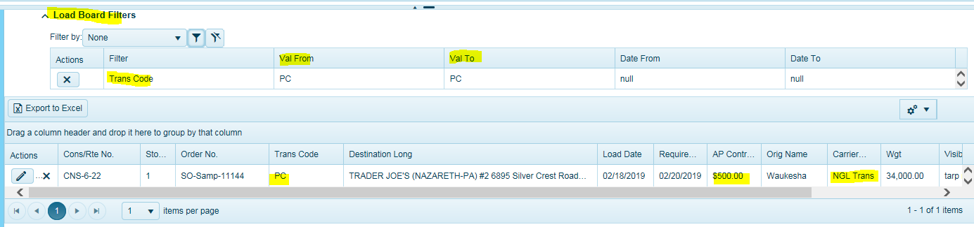

When carrier accepts the load, the system will automatically set it to PB status (finalized-meaning carrier accepted the load). Note, the carrier can still reject the load, in which case will set the status to N. User will need to re-book or post load again.
